
Amity University Bengaluru – 562110

Amity Institute of Information Technology

LAB DIGITAL REPORT

LAB DIGITAL REPORT

Student Enrolment Number | A86904824021
Name of the Student | ANANYA B
Programme | BCA
Course Code | CSE1021
Course Title | Python programming
Semester | Fall
Name of the Faculty | Dr.Vigneesh Ramamoorthy
INDEX
S.NO | DATE | EXPERIMENT TITLE
1 | 19-09-2025 | VARIABLES & DATA TYPES
2 | 19-09-2025 | OPERATORS
3 | 22-09-2025 | TYPE CONVERSION
4 | 22-09-2025 | BASIC I/O
5 | 26-09-2025 | MATH FUNCTIONS
6 | 26-09-2025 | CONSTANTS REASSIGNMENT
7 | 29-09-2025 | TYPE CHECKING
8 | 29-09-2025 | FORMATTED OUTPUT
9 | 10-10-2025 | CONDITIONALS
10 | 10-10-2025 | FOR LOOPS
11 | 13-10-2025 | WHILE LOOPS
12 | 13-10-2025 | LOOP CONTROL
13 | 17-10-2025 | PASS STATEMENT
14 | 17-10-2025 | STRING SLICING
15 | 24-10-2025 | STRING METHODS
16 | 24-10-2025 | FUNCTIONS
17 | 27-10-2025 | FUNCTION PARAMETERS
18 | 27-10-2025 | RETURN VALUES
19 | 31-10-2025 | LAMBDA FUNCTION
20 | 31-10-2025 | RECURSION
21 | 14-11-2025 | VARIABLE SCOPE
22 | 14-11-2025 | LIST OPERATIONS
23 | 17-11-2025 | LIST COMPREHENSION
24 | 21-11-2025 | TUPLES
25 | 24-11-2025 | SETS
26 | 28-11-2025 | DICTIONARIES
27 | 01-12-2025 | ARRAYS
28 | 05-12-2025 | EXCEPTION HANDLING
29 | 08-12-2025 | CLASS OBJECT
30 | 12-12-2025 | INHERITANCE
31 | 29-12-2025 | ENCAPSULATION
32 | 02-01-2026 | POLYMORPHISM
33 | 05-01-2026 | ABSTRACTION
34 | 09-01-2026 | MODULES
35 | 10-01-2026 | RANDOM MODULE

EX.NO: 1
Program using variables and data types.
CODE:
num1=22
num1=num1+1
print(num1)
num1=num1*5
print(num1)
num2=num1
print(num1)
print(num2)
OUTPUT:
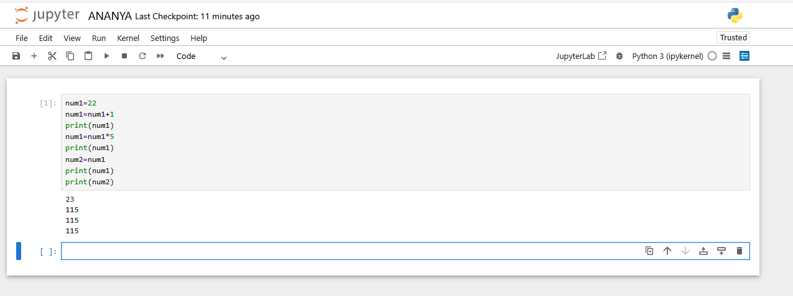
CODE:
Sen = 'A86904824021'
Name = 'ANANYA'
Program = 'BCA'
Phonenumber = 9000968755
DOB = '31 10 2006'
Percentage = 90.56
Are_you_a_student = True
print("Student Details:")
print("Sen:", Sen)
print("Name:", Name)
print("Program:", Program)
print("Phone Number:", Phonenumber)
print("Date of Birth:", DOB)
print("Percentage:", Percentage)
print("Are you a student?", Are_you_a_student)

OUTPUT:
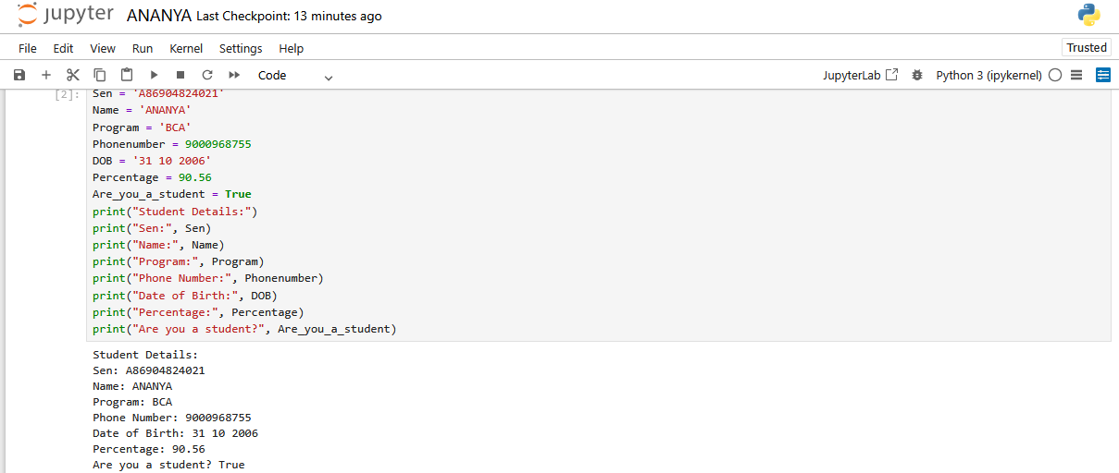

EX.NO: 2
Program using operators.
CODE:
# Arithmetic Operators
A = 4
B = 7
print(A + B)
print(A - B)
print(A * B)
print(A / B)
print(A % B)
OUTPUT:
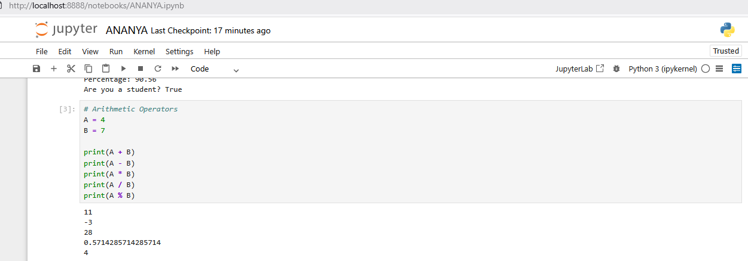

CODE:
# Relational Operators
x = 10
y = 5
z = 20
print(x == y)
print(x != z)
print(x < y)
print(z > y)
print(z <= y)

OUTPUT:
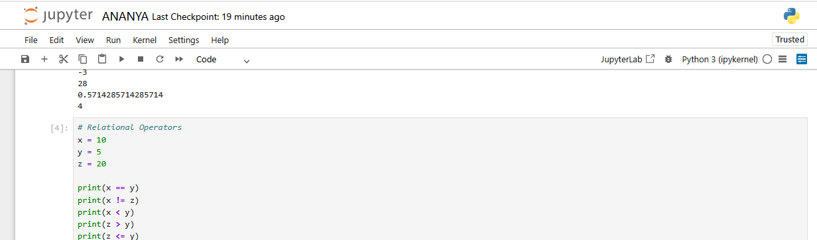

CODE:
# Assignment Operators
x = 10
y = 5
x = y
print(x)
x += y
print(x)
x -= y
print(x)

OUTPUT:
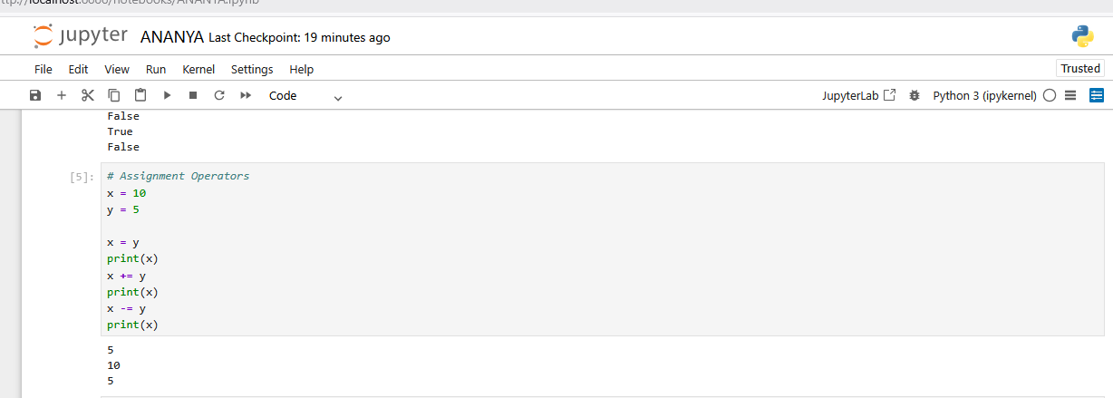

CODE:
# Logical Operators
x = 5
y = 5
z = 20
print((x < y) and (x == y))
print((z > y) and (x == y))
print((x < y) or (x == y))
print((z > y) or (x == y))
a = (x == y)
print(a)
p = not a
print(p)
q = (z < x)
print(q)
s = not q
print(s)

OUTPUT:
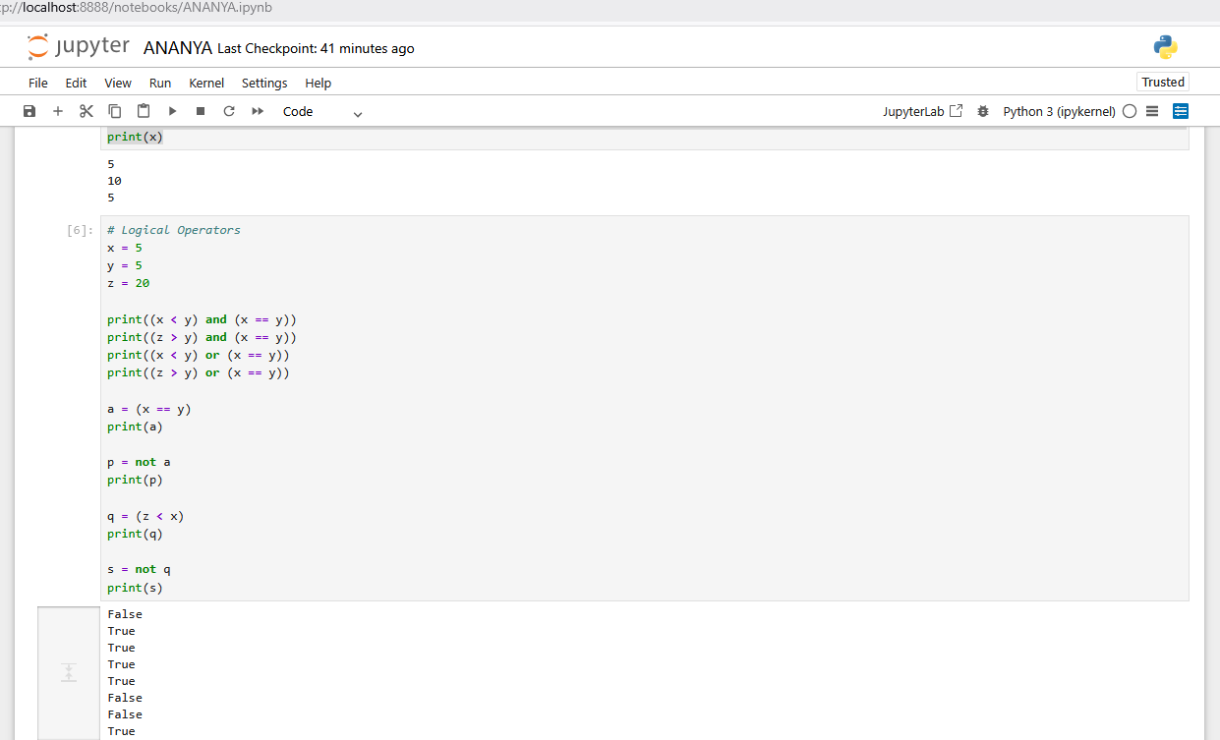

EX.NO: 3
Program using type conversion.
CODE:
print("===== TYPE CONVERSION PROGRAM =====")
print("\nInteger to Float")
a = 10
b = float(a)
print(a)
print(b)
print("\nFloat to Integer")
x = 7.8
y = int(x)
print(x)
print(y)
print("\nInteger to String")
num = 56
s = str(num)
print(num)
print(s)
print("\nString to Integer")
p = "100"
q = int(p)
print(p)
print(q)
print("\nString to Float")
m = "20.5"
n = float(m)
print(m)
print(n)
print("\nBoolean to Integer")
print(int(True))
print(int(False))
print("\nInteger to Boolean")
print(bool(1))
print(bool(0))
print("\nString Concatenation")
s1 = "Kalpa"
s2 = "DV"
print(s1 + s2)
print("\nString + Integer")
age = 20
print("Age is " + str(age))
OUTPUT:
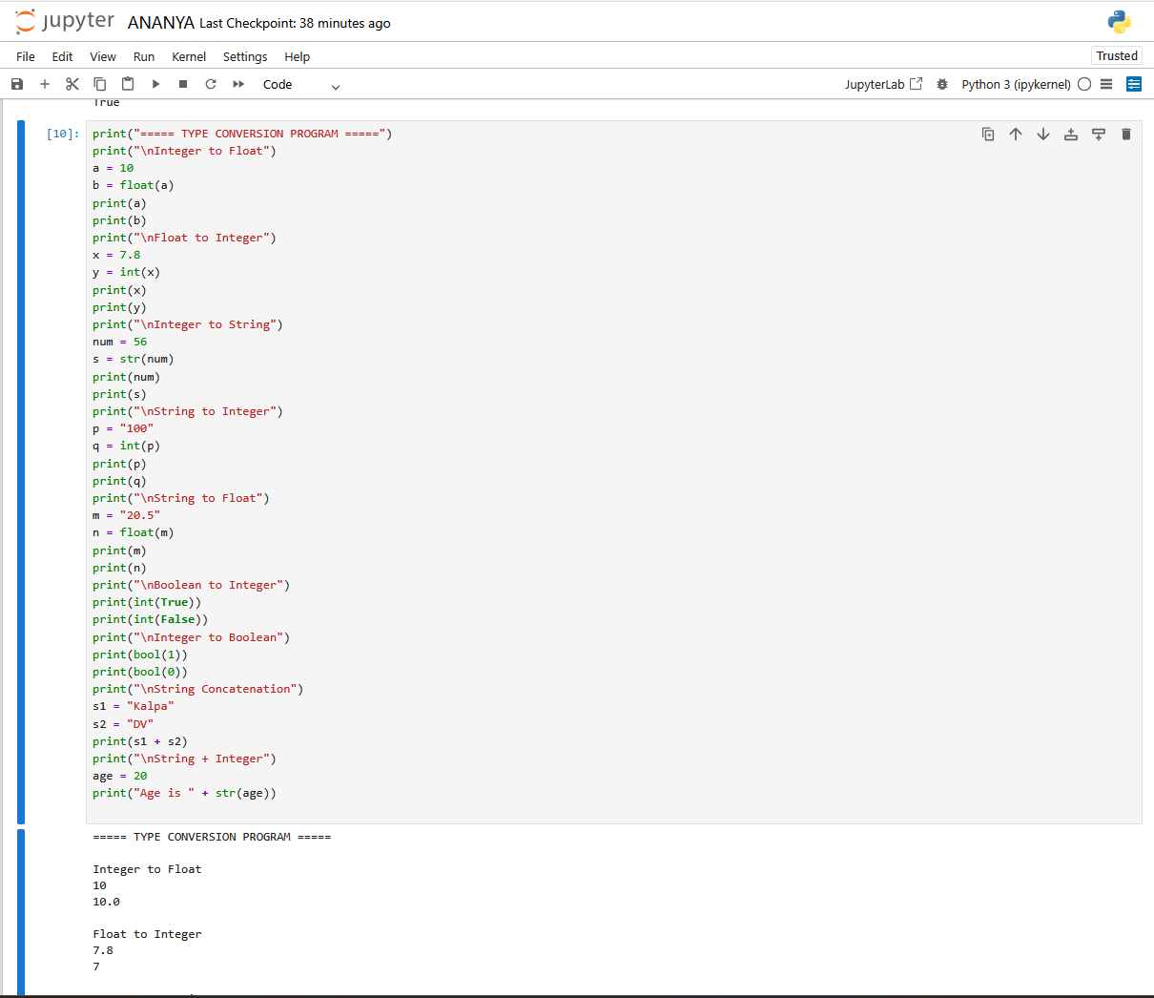
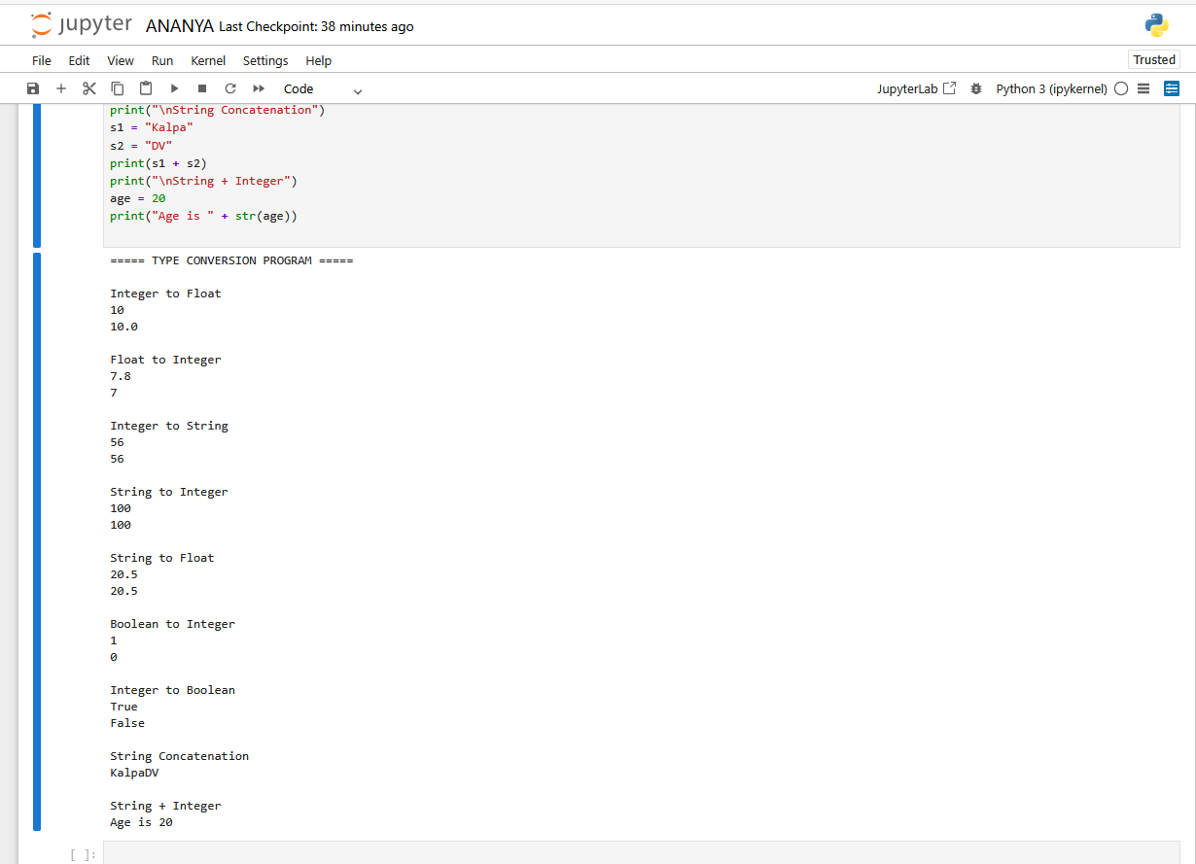

EX.NO: 4
Program for basic input/output.
CODE:
print("===== BASIC INPUT OUTPUT PROGRAM =====")
name = input("Enter your name: ")
age = int(input("Enter your age: "))
print("Name:", name)
print("Age:", age)
num1 = int(input("\nEnter first number: "))
num2 = int(input("Enter second number: "))
print("\nAddition:", num1 + num2)
print("Subtraction:", num1 - num2)
print("Multiplication:", num1 * num2)
print("Division:", num1 / num2)
course = input("\nEnter your course name: ")
print("Course:", course)
price = float(input("\nEnter price: "))
quantity = int(input("Enter quantity: "))
total = price * quantity
print("Total cost:", total)
OUTPUT:
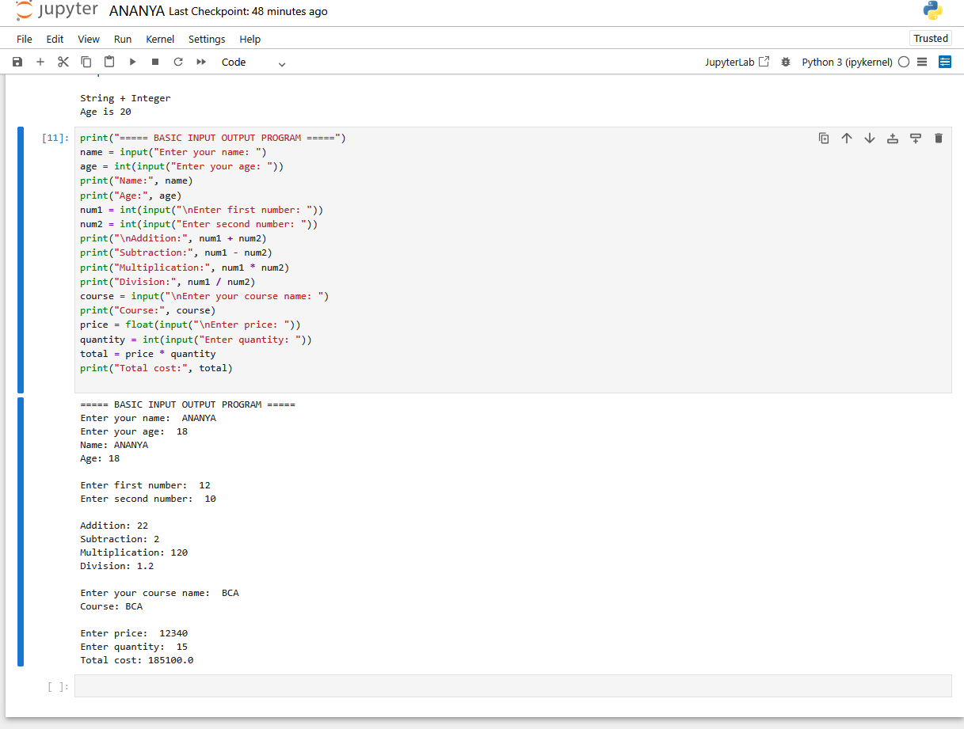

EX.NO: 5
Program using math library functions – sqrt, power, ceil, floor
CODE:
import math
print("===== MATH LIBRARY FUNCTIONS =====")
num1 = float(input("Enter a number: "))
square_root = math.sqrt(num1)
print("Square root:", square_root)
square_root1 = math.sqrt(36)
print("Square root of 36:", square_root1)
square_root2 = math.sqrt(1025)
print("Square root of 1025:", square_root2)
square_root3 = math.sqrt(2025)
print("Square root of 2025:", square_root3)
power_value = math.pow(4, 3)
print("4 power 3:", power_value)
power_value1 = math.pow(8, 6)
print("8 power 6:", power_value1)
a = float(input("Enter a number: "))
floor_value = math.floor(a)
ceil_value = math.ceil(a)
print("Floor value:", floor_value)
print("Ceil value:", ceil_value)

OUTPUT:
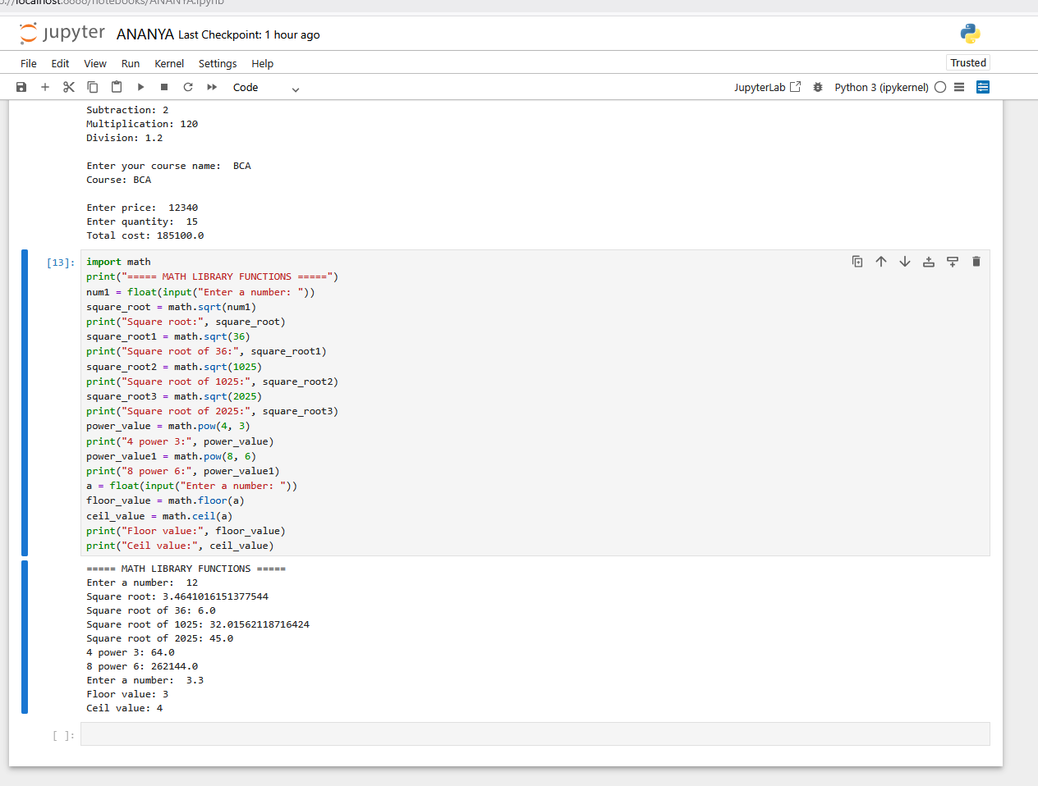

EX.NO: 6
Program with constants, variables and demonstrate reassignment.
CODE:
PI = 3.147
PASS = 48
age = 18
a = 5
print(a)
a = a + 5
print(a)
a = a * a
print(a)
radius = 5
area = PI * (radius ** 2)
print(area)
a = 526 + 4 - 7 * 2
print(a)
OUTPUT:
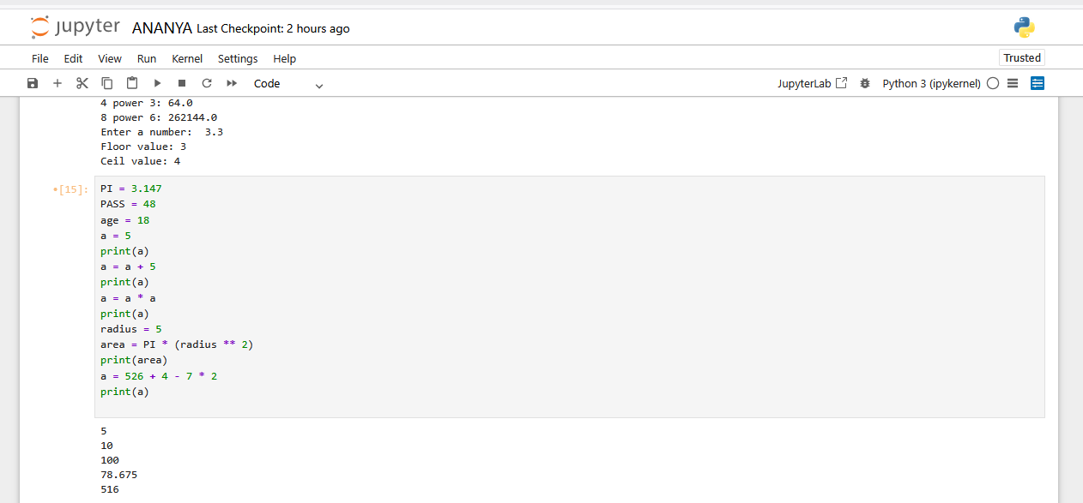
EX.NO: 7
Program to check type of object using type() and isinstance()
CODE:
num1 = 5.6
print(type(num1))
name = "anu"
print(type(name))
adult = True
print(type(adult))
a = 10
print(isinstance(a, int))
print(isinstance(name, bool))
print(isinstance(name, str))
sname = "ananya"
sen = 24021
weight = 45
print(sname)
print(sen)
print(weight)
print(isinstance(sname, str))
print(isinstance(sen, int))
print(isinstance(weight, float))
print(type(sname))
OUTPUT:
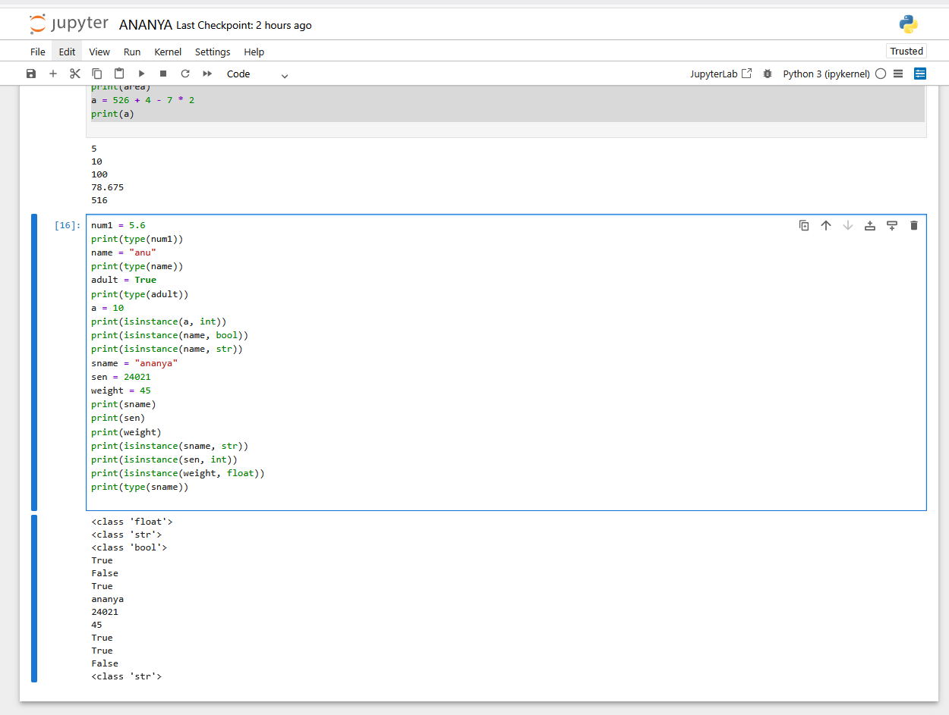
EX.NO: 8
Program with formatted output using f-strings
CODE:
sname = "ananya"
sen = 24021
weight = 45
print(f"my name is {sname}")
print(f"my thuka is {weight}")
print(f"my sen is {sen}")

OUTPUT:
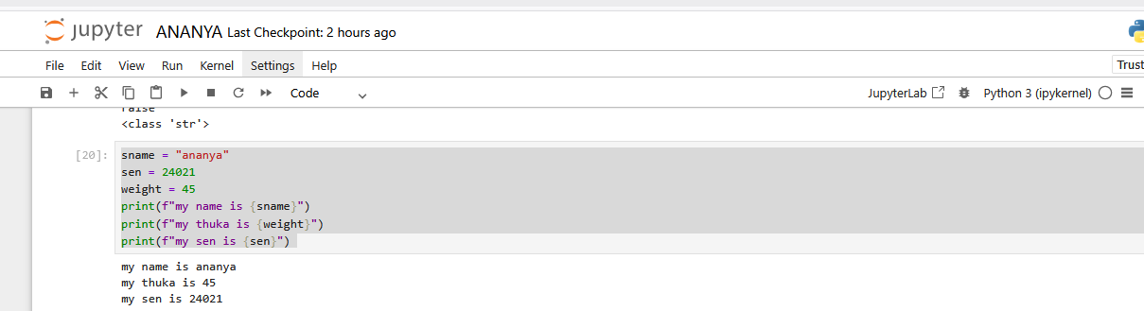

EX.NO: 9
Program combining all if-types – if, if–else, if–elif–else, nested if.
CODE:
attendance = 90
age = 19
marks = 85
if attendance > 75:
print("Attendance Status: Eligible")
else:
print("Attendance Status: Ineligible")
print("---------------------------")
if age >= 18:
print("Voting Status: Eligible for voting")
else:
print("Voting Status: Ineligible for voting")
print("---------------------------")
if marks >= 90:
print("Grade: A")
elif marks >= 80:
print("Grade: B")
elif marks >= 70:
print("Grade: C")
elif marks >= 60:
print("Grade: D")
elif marks >= 50:
print("Grade: E")
else:
print("Grade: Fail")
if marks >= 40:
print("Exam Status: You passed the exam.")
if marks >= 75:
print("Class: Distinction")
elif marks >= 60:
print("Class: First Class")
else:
print("Class: Second Class")
else:
print("Exam Status: You failed the exam")
OUTPUT:
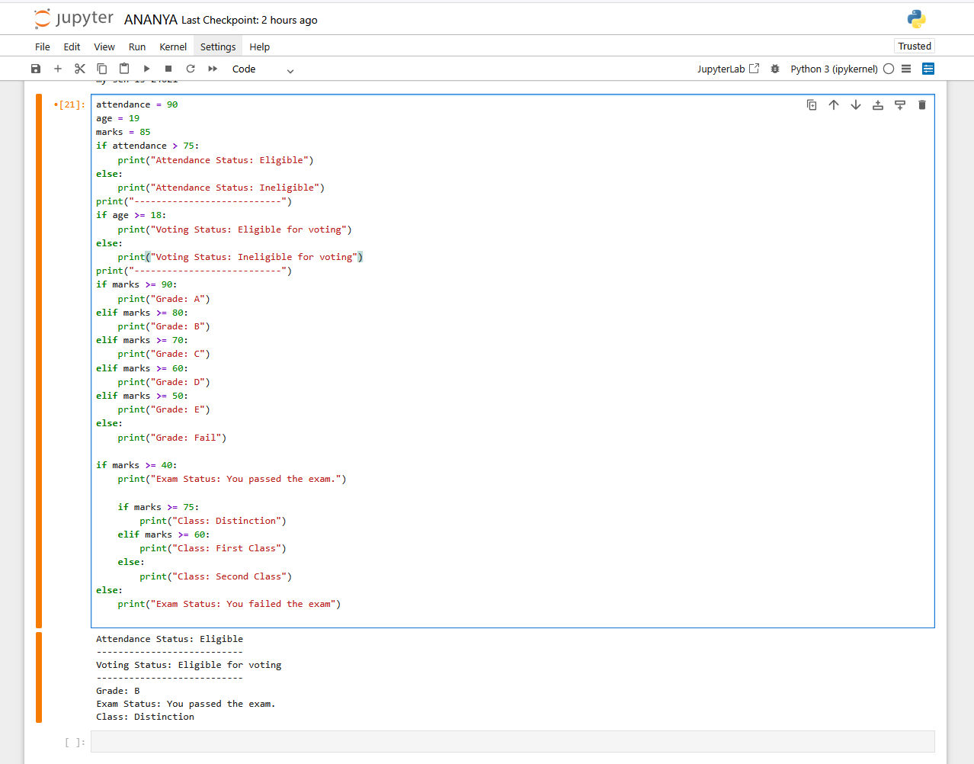
EX.NO: 10
Program with for loop, for with else block, nested for.
CODE:
names = ["ananya", "chethan", "pushpa"]
for name in names:
print(name)
print("a) range(5)")
for i in range(5):
print(i, end=" ")
print("b) range(3, 10)")
for i in range(3, 10):
print(i, end=" ")
print("c) range(2, 12, 3)")
for i in range(2, 12, 3):
print(i, end=" ")
for i in range(len(names)):
print(i, names[i])
for i in range(1, 6):
for j in range(1, 6):
print(i * j, end=" ")
print()
find = "pavan"
for x in names:
if x == find:
print("Eureka! Found it:", x)
break
else:
print("Sadly, not found")

OUTPUT:
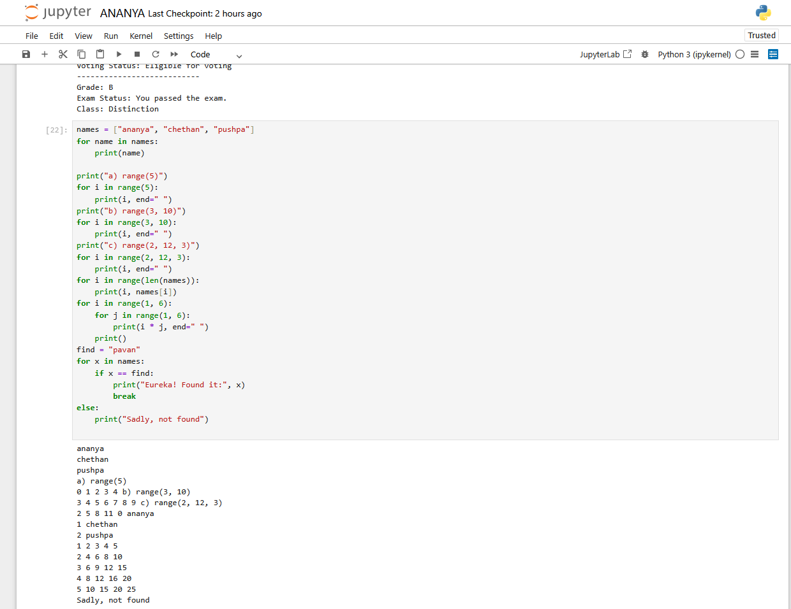
EX.NO: 11
Program with while loop and while else.
CODE:
while i <= 5:
print(i)
i = i + 1
chocolate = 5
while chocolate > 0:
print("Eating a candy and chocolate")
chocolate = chocolate - 1
else:
print("No candy left")

OUTPUT:
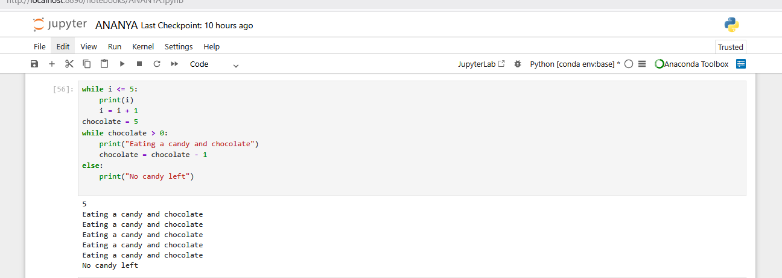

EX.NO: 12
Program with loop control – break and continue.
CODE:
for x in range(1, 10):
if x == 5:
break
print(x)
for x in range(1, 10):
if x == 5:
continue
print(x)
names = [" sony", "moni", "teju", "chinni", "anni"]
for n in names:
if n == "anni":
print("Found:", n)
break
else:
print("Name not found")
for n in names:
if n == "anni":
print("Found:", n)
continue
print("Checking:", n)
OUTPUT:
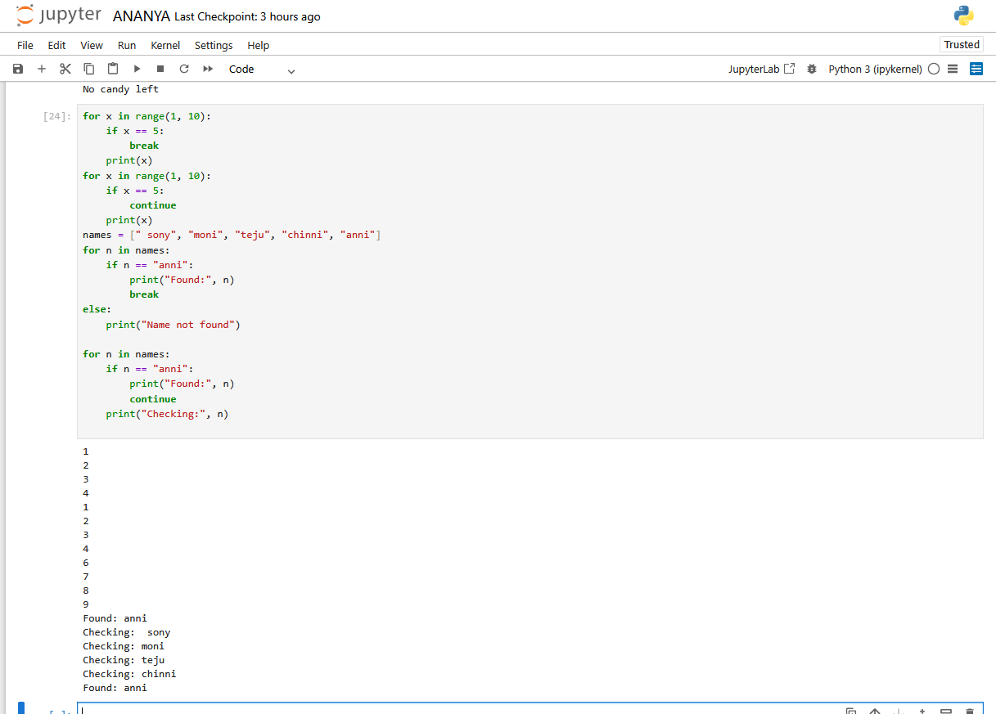
EX.NO: 13
Program with pass statement – Empty function placeholder.
CODE:
def future_function():
pass
class Student:
pass
print("Program started")
age = 20
if age >= 18:
pass
else:
print("Minor")
for i in range(3):
pass
count = 1
while count <= 3:
pass
count += 1
try:
x = 10
except:
pass
print("Program ended")

OUTPUT:
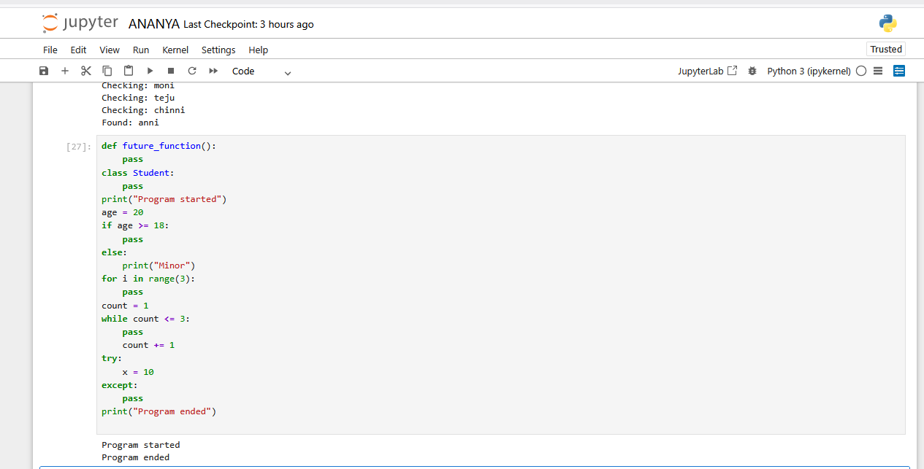

EX.NO: 14
Program with string indexing and slicing.
CODE:
date = "31-10-2006"
dd = date[0:2]
mm = date[3:5]
yyyy = date[6:10]
print("Day:", dd)
print("Month:", mm)
print("Year:", yyyy)
print("---------------------------")
name = "ananya"
print(name[0])
print(name[2])
print(name[3])
print(name[5])
print(name[4])

OUTPUT:
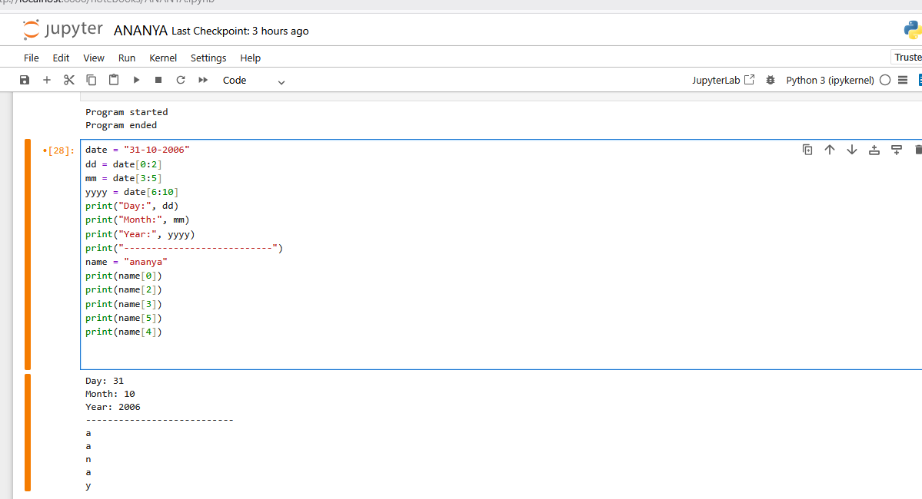

EX.NO: 15
Program with string methods and string validation.
CODE:
username = " Ananya "
password = "Amity123"
print("Original username:", repr(username))
print("Lower case:", username.lower())
print("Upper case:", username.upper())
print("Strip spaces:", username.strip())
print("Swap case:", username.swapcase())
username_clean = username.strip().lower()
print("Cleaned username:", username_clean)
print("Is username alphabetic?", username_clean.isalpha())
print("Is password alphabetic?", password.isalpha())
print("Is password alphanumeric?", password.isalnum())
print("Is password long enough?", len(password) >= 6)
print("Password uppercase:", password.upper())
print("Password reversed:", password[::-1])
print("--------------------------------")
text = " Hello world "
print("Original text:", repr(text))
print("Lower case:", text.lower())
print("Upper case:", text.upper())
print("Strip spaces:", text.strip())
print("Replace:", text.replace("world", "python"))
print("Split:", text.split())
print("Swap case:", text.swapcase())
print("--------------------------------")
word1 = "Python123"
word2 = "12345"
word3 = "Python"
word4 = "hello"
word5 = "HELLO"
print("word1 is alphanumeric:", word1.isalnum())
print("word2 is digit:", word2.isdigit())
print("word3 is alphabetic:", word3.isalpha())
print("word4 is lowercase:", word4.islower())
print("word5 is uppercase:", word5.isupper())

OUTPUT:
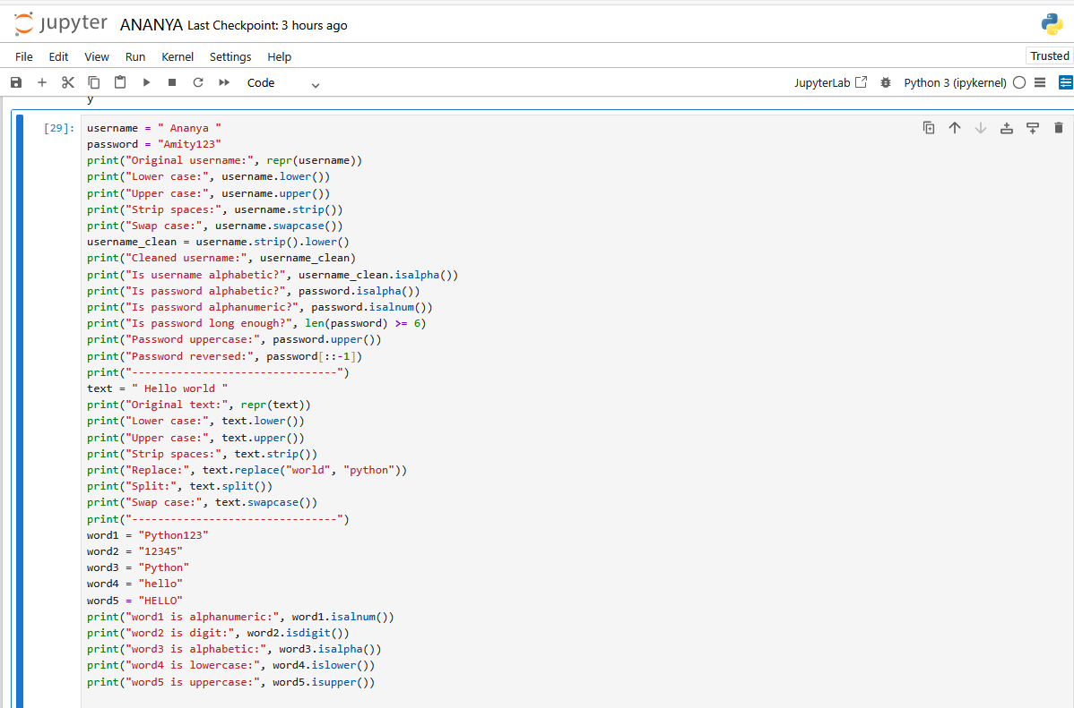
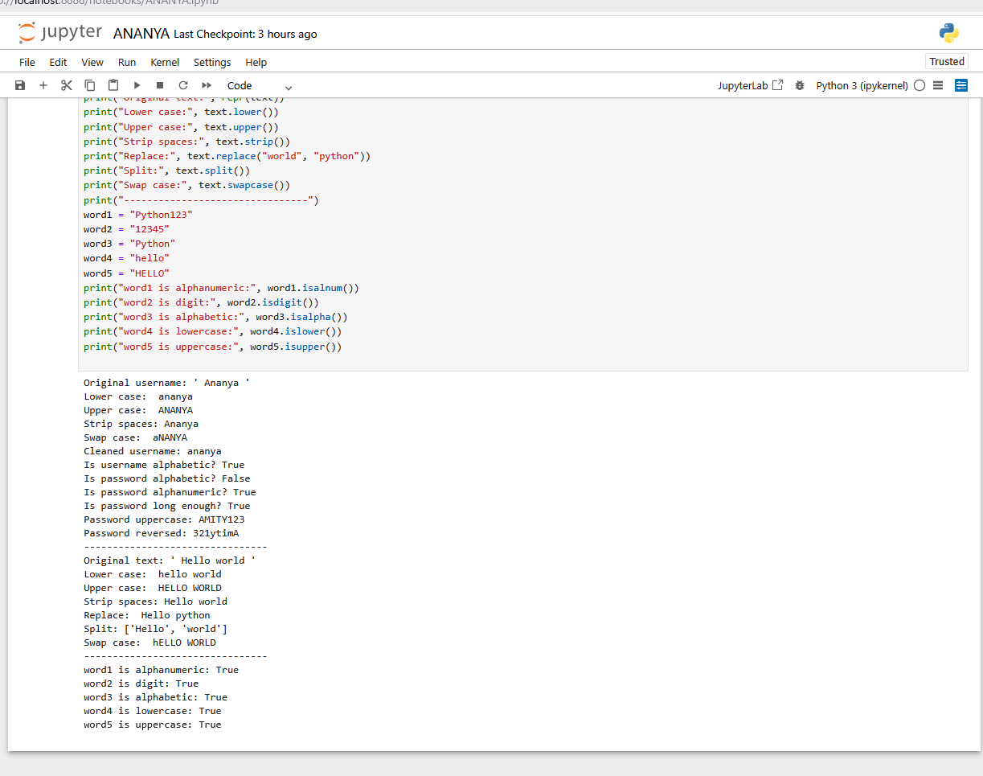
EX.NO: 16
Program defining and calling a function.
CODE:
def get_student():
sname = input("Say your name: ")
age = input("Enter your age: ")
phone = input("Enter your phone number: ")
return sname, age, phone
def show_student(sname, age, phone):
print("\nStudent Name:", sname)
print("Student Age:", age)
print("Student Phone:", phone)
sname, age, phone = get_student()
show_student(sname, age, phone)
def square(num):
print("Square:", num * num)
square(5)

OUTPUT:
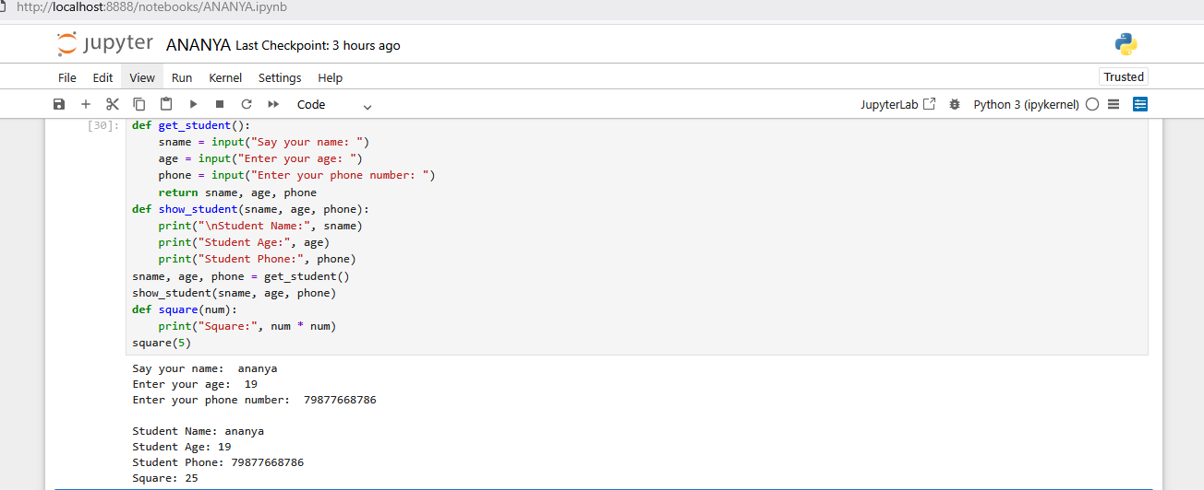

EX.NO: 17
Program with function parameters.
CODE:
def demo_function(a, b, c=10, *args, **kwargs):
print("Positional parameter a:", a)
print("Positional parameter b:", b)
print("Default parameter c:", c)
print("Variable length arguments:")
for value in args:
print(value)
print("Keyword variable-length arguments:")
for key, value in kwargs.items():
print(key, ":", value)
demo_function(
5,
10,
20,
1, 2, 3, 4,
name="Ananya",
age=18,
city="Bangalore"
)

OUTPUT:
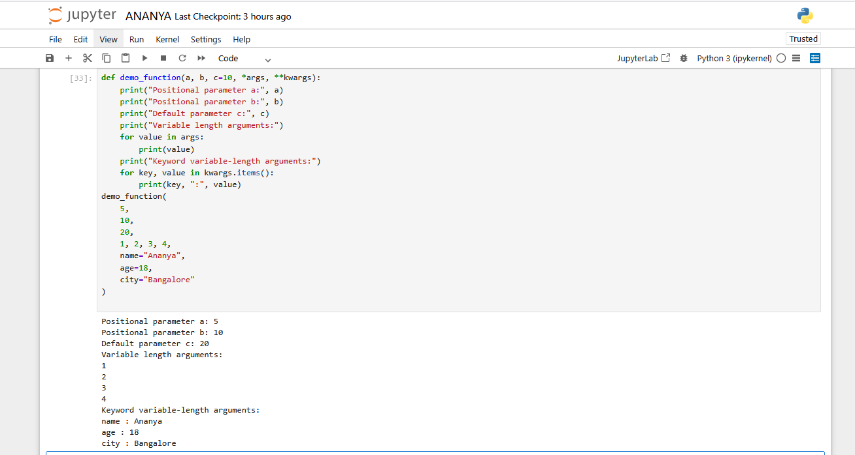

EX.NO: 18
Program with return values and default arguments.
CODE:
def calculate_total(price, quantity=1):
total = price * quantity
return total
bill1 = calculate_total(100)
bill2 = calculate_total(100, 3)
print("Bill 1 (default quantity):", bill1)
print("Bill 2 (given quantity):", bill2)

OUTPUT:
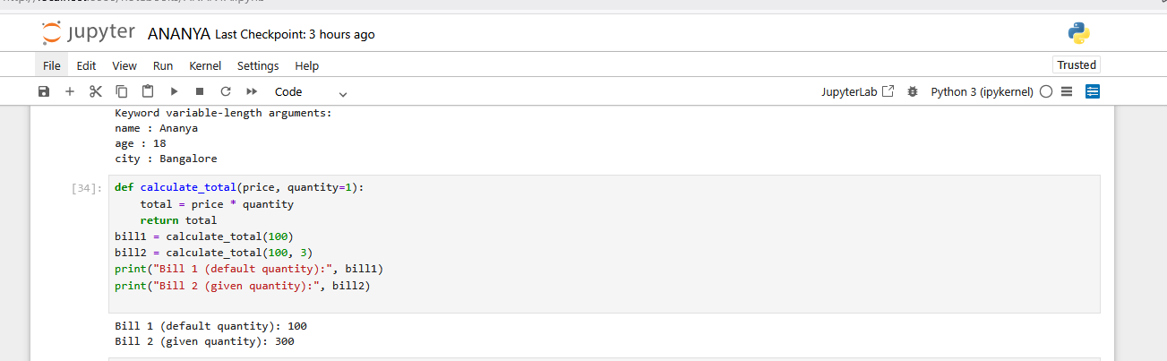

EX.NO: 19
Program with lambda function.
CODE:
square = lambda x: x * x
print(square(6))
add = lambda a, b: a + b
print(add(10, 5))
grade = lambda marks: "Pass" if marks >= 40 else "Fail"
print(grade(75))
print(grade(28))

OUTPUT:
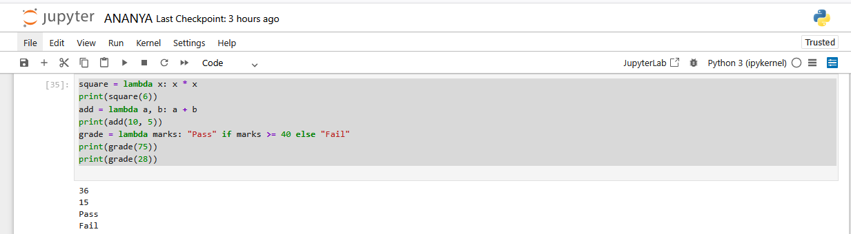

EX.NO: 20
Program with recursion.

CODE:
def factorial(n):
if n == 1:
return 1
return n * factorial(n - 1)
print("Factorial of 5:", factorial(5)) # 120
def fibonacci(n):
if n <= 1:
return n
return fibonacci(n - 1) + fibonacci(n - 2)
for i in range(8):
print(fibonacci(i), end=" ")

OUTPUT:
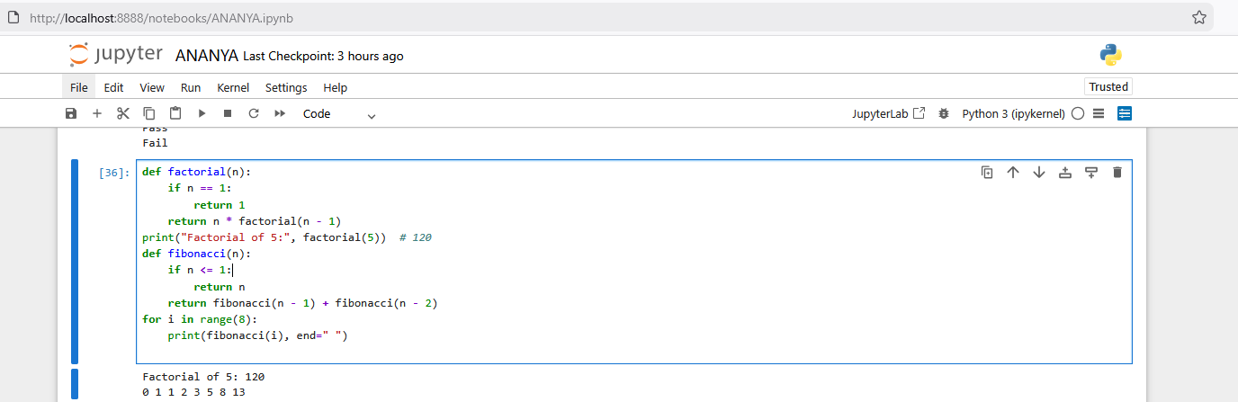

EX.NO: 21
Program to demonstrate scope – local vs global variable.
CODE:
y = 50
def local_example():
x = 10
print("Inside function (local): x =", x)
print("Inside function (global): y =", y)
def global_example():
global y
y = y + 20
print("Inside function after modifying global: y =", y)
local_example()
print("Global variable y before modification:", y)
global_example()
print("Global variable y after modification:", y)
def my_function():
x = 10
print("Inside function:", x)
my_function()
y = 16
def my_function2():
global y
x = 10
y = y + x
print("Inside function:", x)
my_function2()
print("Sum:", y)
balance = 1000
def deposit(amount):
global balance
balance = balance + amount
print("Deposited:", amount)
def withdraw(amount):
global balance
if amount <= balance:
balance = balance - amount
print("Withdraw:", amount)
else:
print("Insufficient balance!")
deposit(500)
withdraw(300)
print("Final balance:", balance)
OUTPUT:
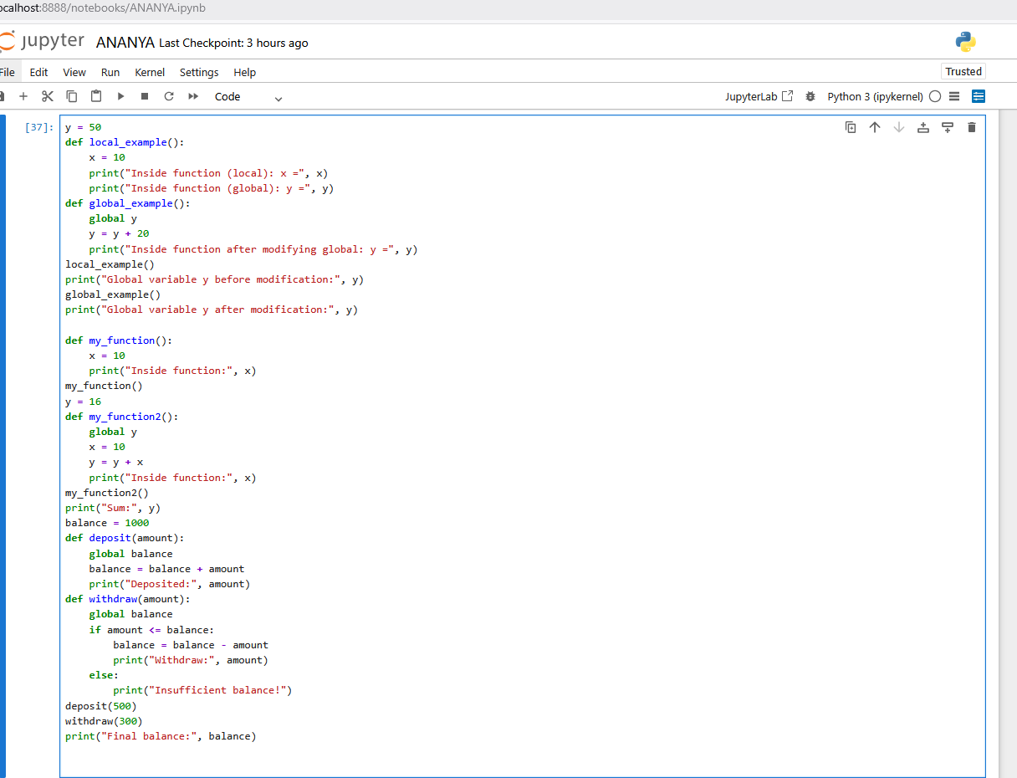
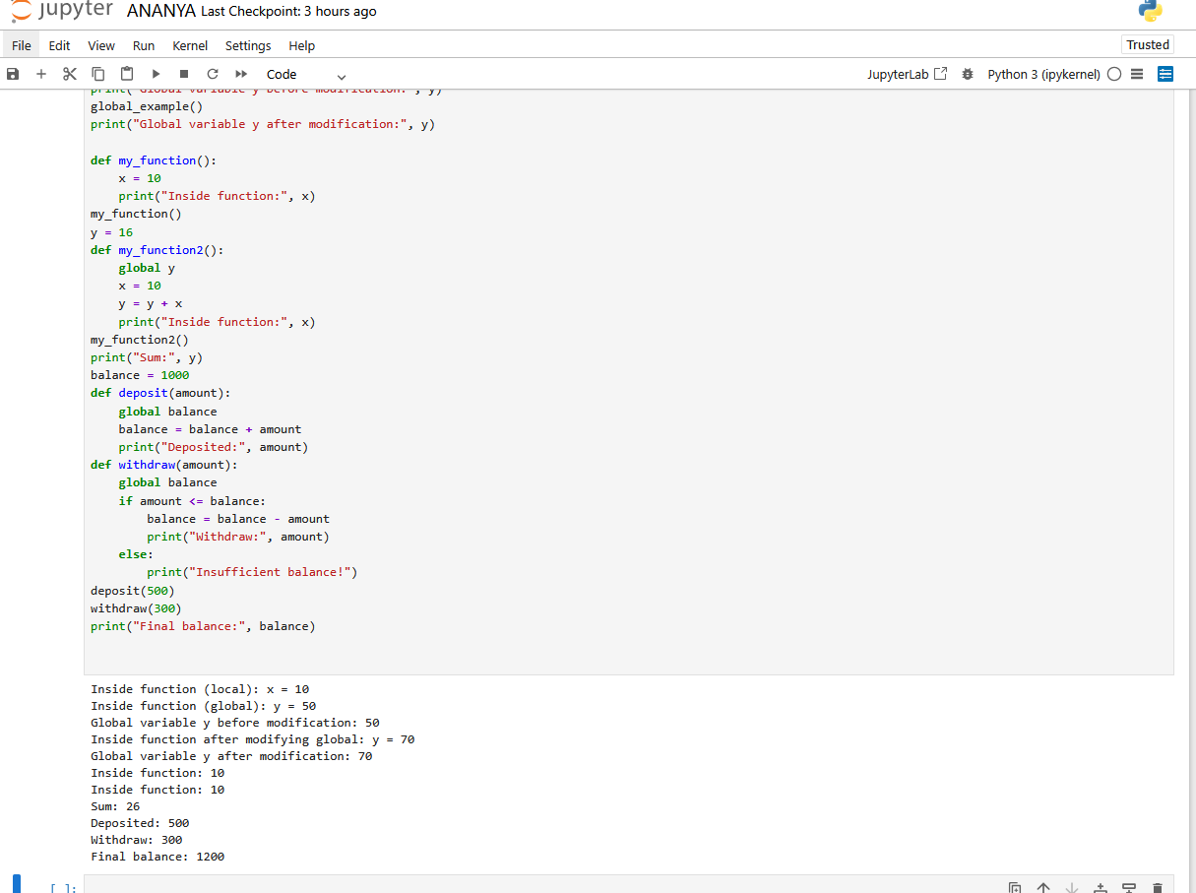

EX.NO: 22
Program with list operations.
CODE:
c = [82, 44, 6, 12, 17, 3]
c.sort()
print("Sorted numbers:", c)
c.reverse()
print("Numbers in reverse:", c)
name = ["ananya", "mary", "sonali", "zoya", "chaithra"]
name.sort()
print("Sorted names:", name)
name.reverse()
print("Names in reverse:", name)
import array
a = array.array('i', [1, 2, 3, 4, 5])
print("Original array:", a)
a.append(6)
print("After append:", a)
a.remove(3)
print("After remove 3:", a)
temp = [30, 32, 31, 29, 33, 34, 30]
print("Original temperatures:", temp)
for t in temp:
print(t, end=" ")
print("\nNumber of temperatures:", len(temp))
temp.append(44)
print("After append 44:", temp)
temp.insert(3, 28)
print("After insert 28 at index 3:", temp)
temp.remove(33)
print("After remove 33:", temp)
temp.pop(3)
print("After pop at index 3:", temp)
if 33 in temp:
print("Element 33 found")
else:
print("Element 33 not found")
temp.reverse()
print("Reversed temperatures:", temp)

OUTPUT:
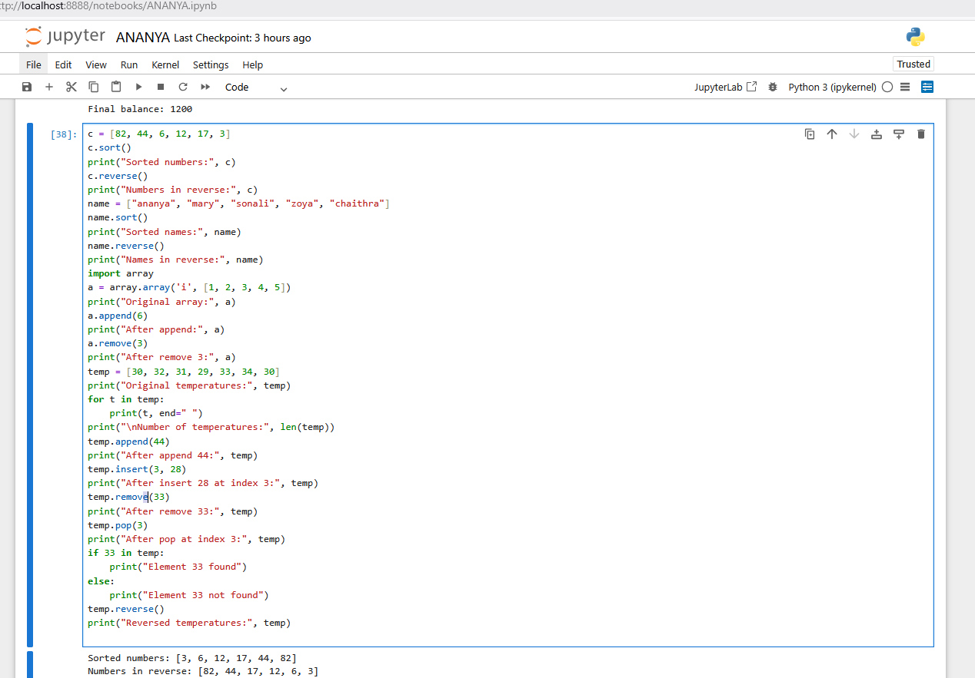
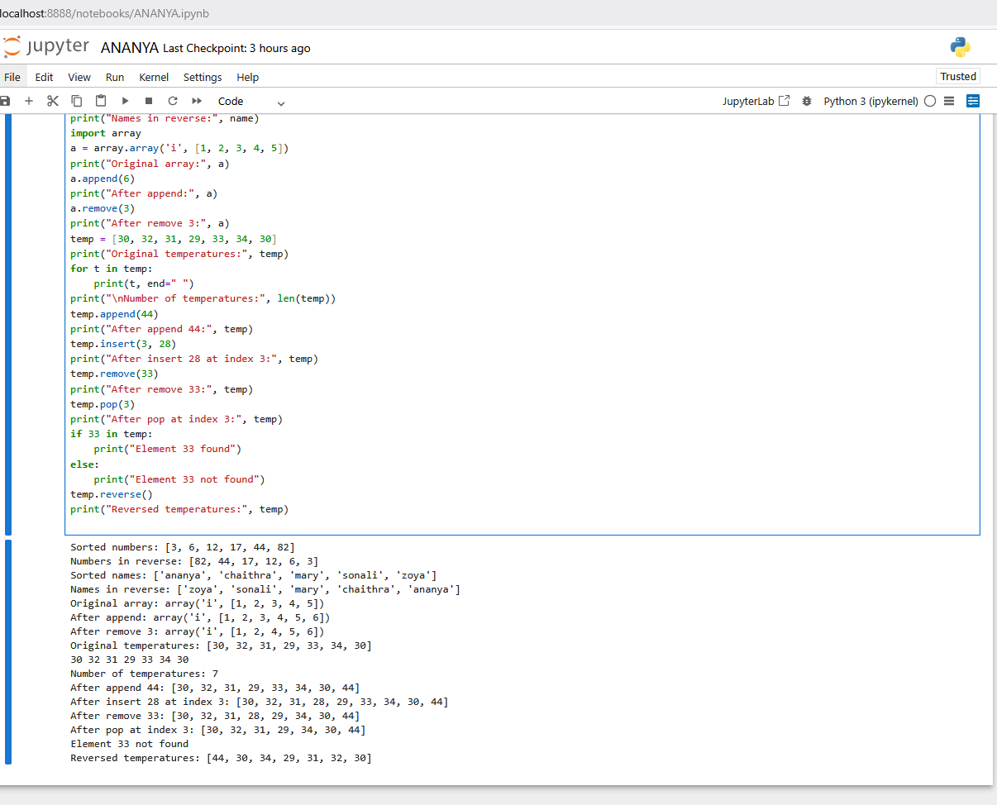

EX.NO: 23
Program with list comprehension.
CODE:
squares = [x*x for x in range(1, 11)]
print("Squares:", squares)
evens = [x for x in range(1, 21) if x % 2 == 0]
print("Even numbers:", evens)
names = ["ananya", "mary", "sonali", "zoya", "chaithra"]
upper_names = [name.upper() for name in names]
print("Uppercase Names:", upper_names)
div3 = [x for x in range(1, 31) if x % 3 == 0]
print("Divisible by 3:", div3)
table = [[i*j for j in range(1, 6)] for i in range(1, 6)]
print("Multiplication Table 1-5:")
for row in table:
print(row)
OUTPUT:
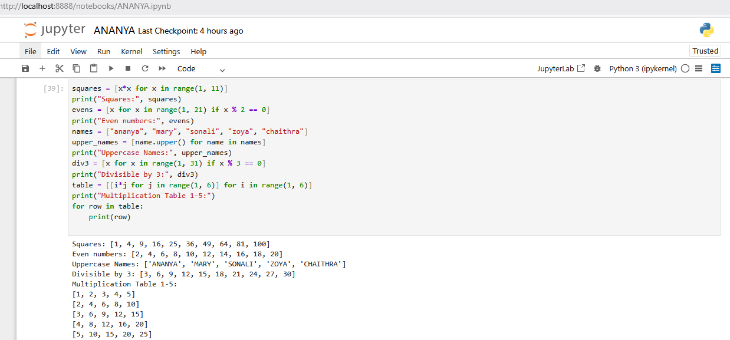

EX.NO: 24
Program with tuple.
CODE:
squares = [x*x for x in range(1, 11)]
print("Squares:", squares)
evens = [x for x in range(1, 21) if x % 2 == 0]
print("Even numbers:", evens)
names = ["ananya", "mary", "sonali", "zoya", "chaithra"]
upper_names = [name.upper() for name in names]
print("Uppercase Names:", upper_names)
div3 = [x for x in range(1, 31) if x % 3 == 0]
print("Divisible by 3:", div3)
table = [[i*j for j in range(1, 6)] for i in range(1, 6)]
print("Multiplication Table 1-5:")
for row in table:
print(row)
OUTPUT:
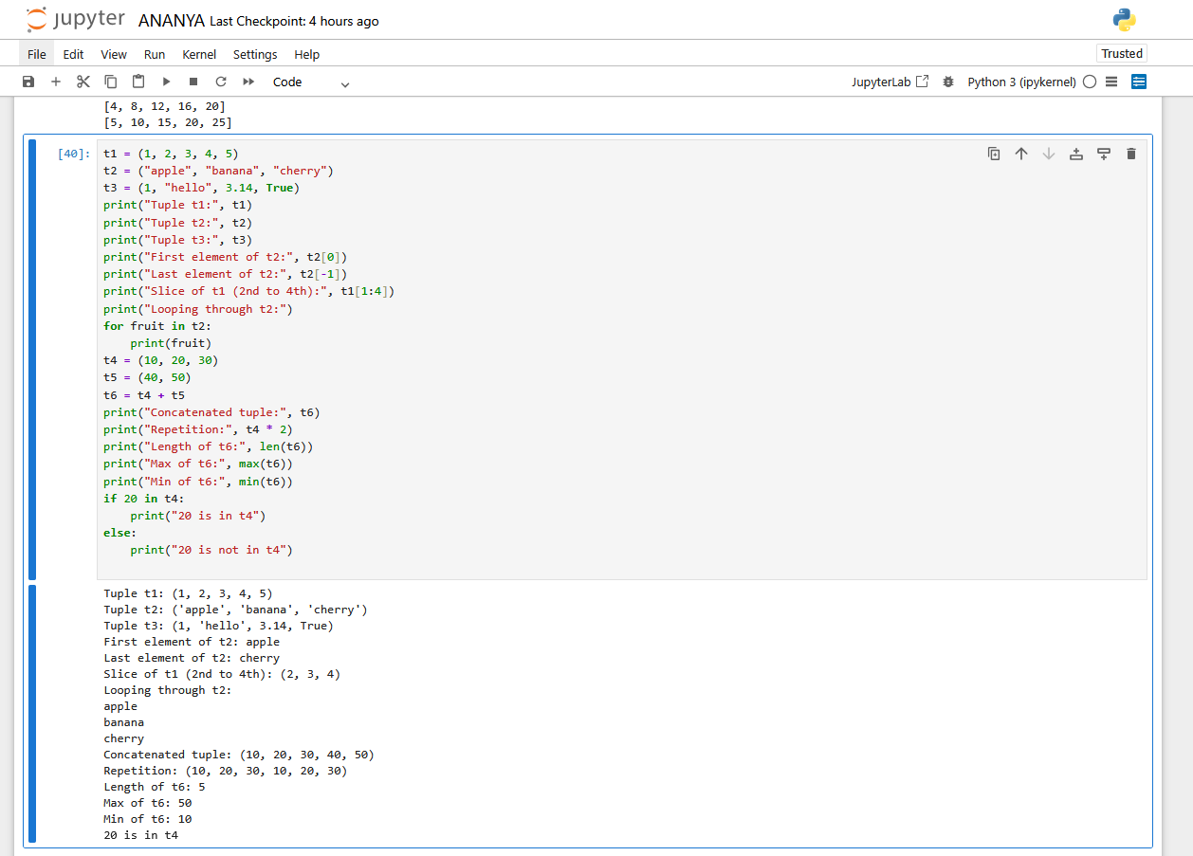
EX.NO: 25
Program with set.
CODE:
s1 = {1, 2, 3, 4, 5}
s2 = set([4, 5, 6, 7, 8])
s3 = {"apple", "banana", "cherry", "apple"}
print("Set s1:", s1)
print("Set s2:", s2)
print("Set s3 (duplicates removed):", s3)
s1.add(6)
print("After adding 6 to s1:", s1)
s1.remove(2)
print("After removing 2 from s1:", s1)
s1.discard(10)
print("After discarding 10 from s1:", s1)
print("Union of s1 and s2:", s1 | s2)
print("Intersection of s1 and s2:", s1 & s2)
print("Difference s1 - s2:", s1 - s2)
print("Symmetric Difference s1 ^ s2:", s1 ^ s2)
print("Loop through s2:")
for item in s2:
print(item, end=" ")
print("Is 5 in s1?", 5 in s1)
print("Is 10 in s1?", 10 in s1)

OUTPUT:
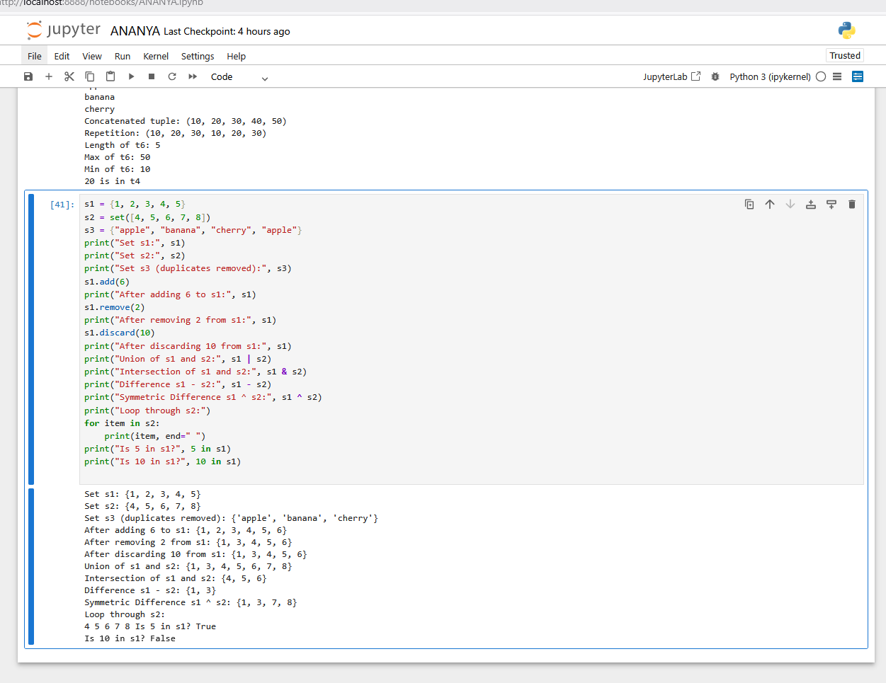
EX.NO: 26
Program with dictionary.
CODE:
student = {
"name": "Ananya",
"age": 18,
"phone": "9876543210"
}
marks = {
"Math": 95,
"Physics": 88,
"Chemistry": 92
}
print("Student Dictionary:", student)
print("Marks Dictionary:", marks)
print("Student name:", student["name"])
print("Physics marks:", marks["Physics"])
student["grade"] = "A"
print("Updated Student Dictionary:", student)
marks["Math"] = 98
print("Updated Marks Dictionary:", marks)
student.pop("phone")
print("After removing phone:", student)
print("Loop through student dictionary:")
for key, value in student.items():
print(key, ":", value)
print("Is 'age' in student?", "age" in student)
print("Is 'phone' in student?", "phone" in student)
OUTPUT:
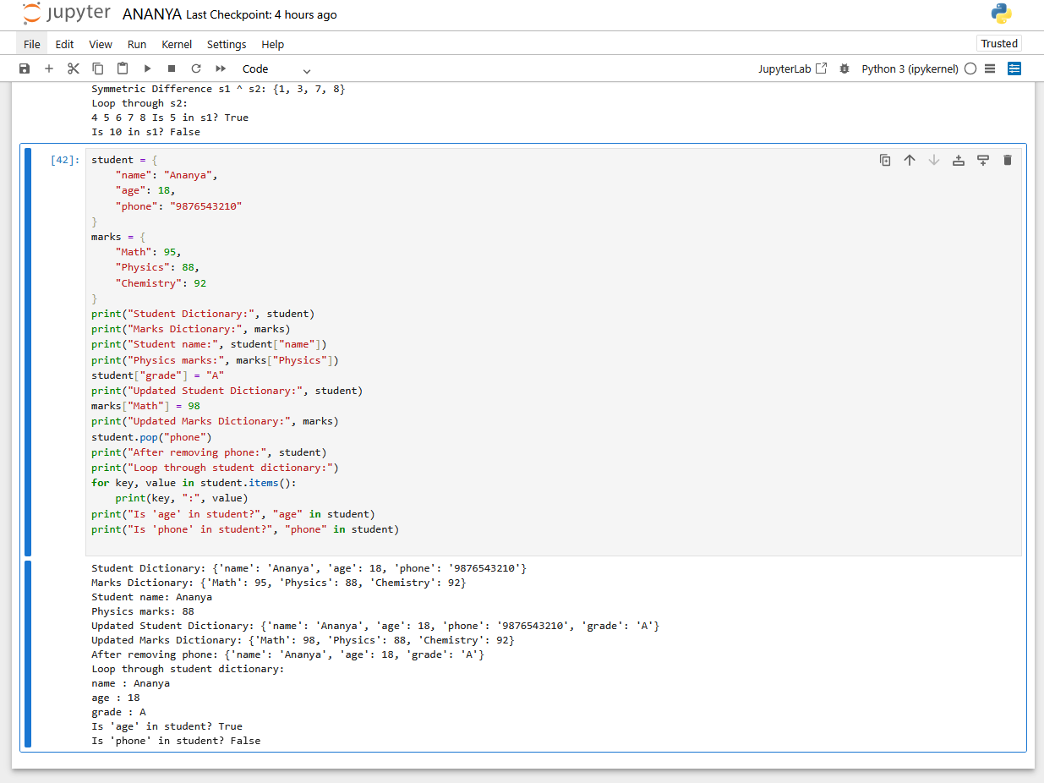
EX.NO: 27
Program with Array.
CODE:
import array
a = array.array('i', [1, 2, 3, 4, 5])
print("Original array:", a)
print("First element:", a[0])
print("Last element:", a[-1])
a.append(6)
a.insert(2, 10)
print("After adding elements:", a)
a.remove(3)
popped_element = a.pop(4)
print("After removing elements:", a)
print("Popped element:", popped_element)
print("Array elements:")
for item in a:
print(item, end=" ")
print()
a.reverse()
print("Reversed array:", a)
print("Length of array:", len(a))
if 10 in a:
print("Element 10 found in array")
else:
print("Element 10 not found")

OUTPUT:
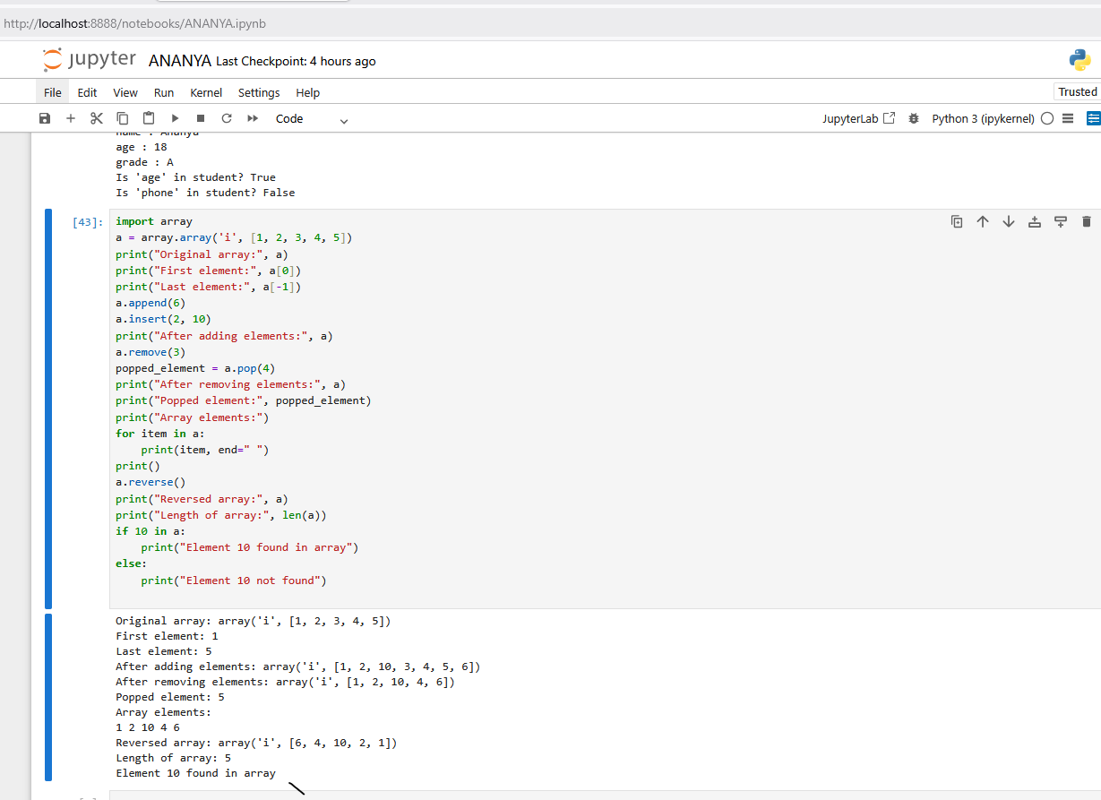
EX.NO: 28
Program with .
CODE:

